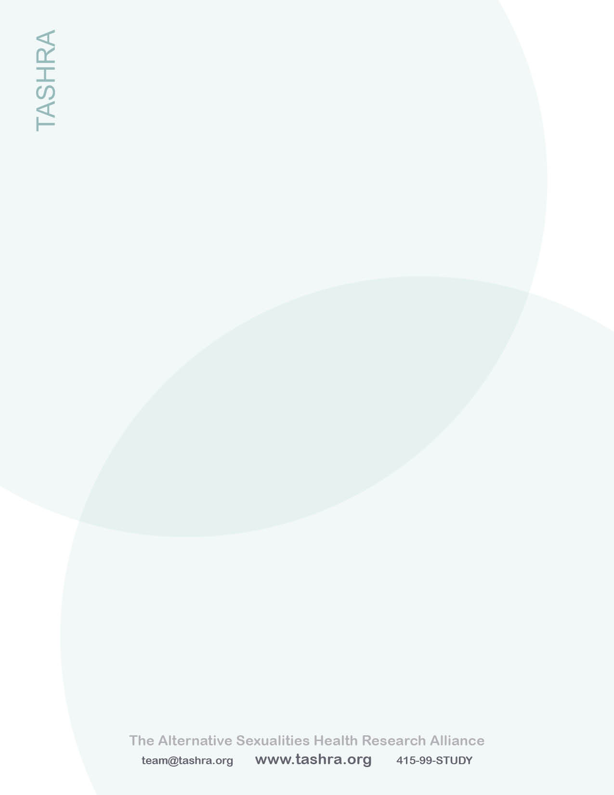

TASHRA MEDIA SHEET 2014

The Alternative Sexualities Health Research Alliance (TASHRA) is a community-based organization whose mission is to improve the physical and mental health of people who engage in BDSM, kink and sexual fetishism.* We achieve this by conducting community-based research, educating healthcare professionals and patients, and by fostering the development of kink-friendly healthcare services.

TASHRA was started in 2012 by Jess Waldura, MD, Richard Sprott, PhD, and Anna Randal, MPH DHS, in collaboration with a group of kink community members. Jess Waldura, MD, is a family physician, HIV provider, and researcher at UCSF. Richard Sprott, PhD, is a developmental psychologist and director of the Community-Academic Consortium for Research on Alternative Sexualities (CARAS). Anna Randall, MPH DHS, is a clinical sexologist and researcher in private practice. Our Community Research Advisory Board members are listed on the left.

TASHRA has identified a dramatic shortage of research on the health and healthcare of kinksters, and a global lack of training for healthcare professionals on providing sensitive and knowledgeable care to this population. To address these gaps, TASHRA is currently working on the following projects:

1. **The Kink Health Project. Our pilot study** consists of town-hall meetings, focus groups and interviews of local kinksters to identify issues of importance to patients in their interactions with the healthcare system. *This study is underway and will be completed by fall 2014.* Our second study, **a national survey** of the health and healthcare of kinksters will be launched in October 2014.
2. **Creation and distribution of educational materials** for both patients and healthcare providers on the ABCs of kink health. *Materials are available in print and on our website.*
3. **Professional education seminars and conferences** to medical and mental healthcare students and practitioners. In 2014, we presented seminars at UCSF, Stanford, and Harvard medical schools.
4. **Publication of our research and presentation of our findings** via community and academic/professional channels.

In the near future, we have plans to:

1. **Start a low-cost “kink-friendly” clinic** in San Francisco.
2. **Produce a training video for healthcare professionals**
3. **Organize community empowerment events** to educate kinksters on ways to strengthen their health partnerships with providers.

We are 501c3 non-profit organization and are currently fundraising through local charitable organizations and philanthropists. We will be applying for NIH research funding once our pilot data identifies the main issues of public health importance.

Learn more about us:

Web: www.tashra.org Email: team@tashra.org

Fetlife: fetlife.com/users/2294280 Twitter: @KinkHealth

Facebook: www.facebook.com/tashra.org

TASHRA’s

Community Research Advisory Board

Charles Moser

Crystal (Ham) Mason

Deborah Wade

Eve Minax

Frank Strona

Grae Singer

Keely Kolmes

Larry Shockey

Louann Pironti

Michael Huff

Mollena Williams

Race Bannon

Shay Tiziano

Sister Jezabelle

Yosenio Lewis

* BDSM, kink, and sexual fetishism are terms that describe alternative sexual practices, expressions and identities. For more, go to www.tashra.org