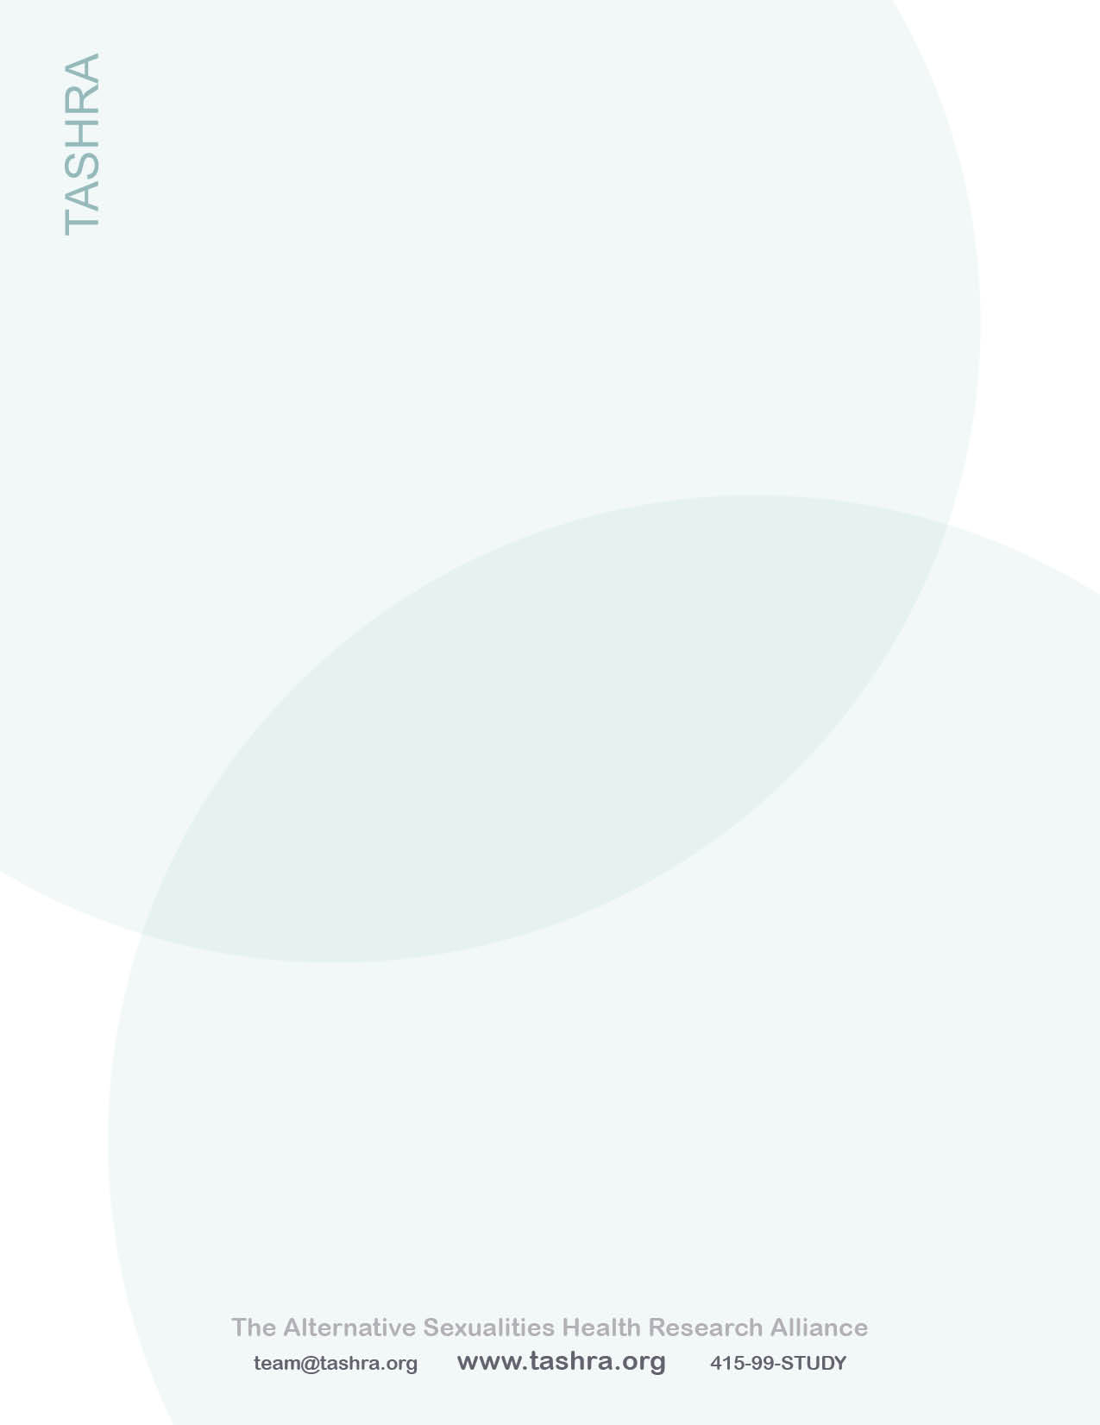

A Closer Look at TASHRA

# Some Terminology

## What is Alternative Sexuality?

* A diverse group of sexual practices, expressions, and identities that fall outside of the sexual mainstream
* Generally includes various types of “kinky” sex, BDSM, and sexual fetishism
* May include consensual non-monogamy (e.g. swinging, polyamory, etc.)
* Sometimes includes minority sexual orientations (gay, lesbian, bisexual, etc.) or gender identities (transgender, genderqueer, etc.)

## What is BDSM?

BDSM is a compound acronym, standing for:

* Bondage and Discipline (B/D)
* Dominance and Submission (D/s)
* Sadism and Masochism (S/M)

**“***It serves as an umbrella label for forms of sexuality which incorporate restraint, pressure, intense sensation, and elements of power exchange between the engaged parties.”  
(Ortmann & Sprott, 2012)*

## What is Kink?

A broad range of alternative (non-normative) practices and identities for the purposes of personal and/or erotic pleasure. Can range from fuzzy handcuffs in the bedroom to full-time master/slave relationship dynamics.*Cf. Kinky, kinkster*

## What is Leather?

An identity within the kink community. Often used by (but not limited to) gay men.

## What is sexual fetishism?

An extreme erotic attraction to anything non-traditionally eroticized. This can be an inanimate object or a particular aspect of a human partner. Common fetishes include shoes, cigars, and materials such as leather.